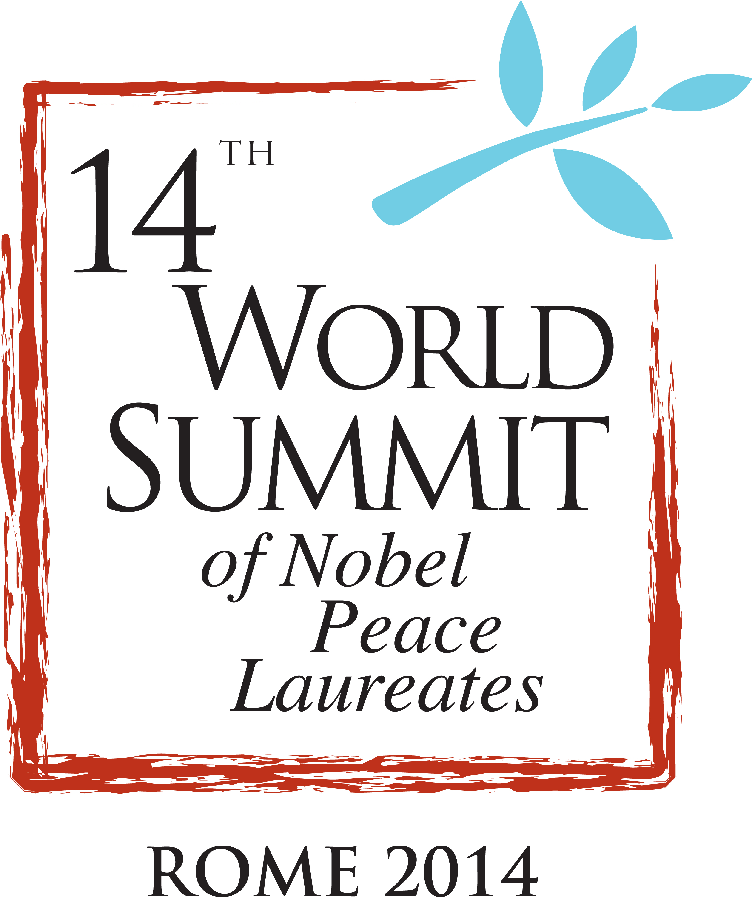
The Nobel Peace Laureates and Peace Laureate Organizations, gathered in Rome for the 14th World Summit of Nobel Peace Laureates from 12 – 14 December, 2014 have issued the following declaration regarding their deliberations:

LIVING PEACE
Final Statement

Nothing is as antagonistic to peace as the human mind without love, compassion, and reverence for life and nature. Nothing is as noble as the human being who chooses to bring love and compassion into action.

This year we honor the legacy of Nelson Mandela. He exemplified the principles for which the Nobel Peace Prize is granted and serves as a timeless example of a truth he lived. As he himself said: “love comes more naturally to the human heart than its opposite.”

He had many reasons to give up hope, even to hate, but he chose love in action. It is a choice we can all make.

We are saddened by the fact that we were not able to honor Nelson Mandela and his fellow Peace Laureates in Cape Town this year because of the refusal of the South African government to grant a visa to H.H. the Dalai Lama to enable him to attend the planned Summit in Cape Town. The 14th Summit, which was moved to Rome, has nevertheless permitted us to consider South Africa’s unique experience in showing that even the most intractable disputes can be resolved peacefully through civic activism and negotiation.

As Nobel Peace Laureates we bear witness that – as has happened in South Africa during the past 25 years - change for the common good can be achieved. Many of us have faced guns and overcome fear with a commitment to live with and for peace.

Peace thrives where governance protects the vulnerable, where the rule of law brings justice and the treasure of human rights, where harmony with the natural world is achieved, and where the benefits of tolerance and diversity are fully realized.

Violence has many faces: prejudice and fanaticism, racism and xenophobia, ignorance and shortsightedness, injustice, gross inequalities of wealth and opportunity, oppression of women and children, forced labor and slavery, terrorism, and war.

Many people feel powerless and suffer in cynicism, selfishness, and apathy. There is a cure: when individuals commit to caring for others with kindness and compassion, they change and they are able to make changes for peace in the world.

It is a universal personal rule: We must treat others as we wish to be treated. Nations, also, must treat other nations as they wish to be treated. When they don’t, chaos and violence follow. When they do, stability and peace are obtained.

We decry the continued reliance on violence as a primary means of addressing differences. There are no military solutions to Syria, Congo, South Sudan, Ukraine, Iraq, Palestine/Israel, Kashmir and other conflicts.

One of the greatest threats to peace is the continuing view of some great powers that they can achieve their goals through military force. This perspective is creating new crisis today. If left unchecked this tendency will inevitably lead to increased military confrontation and to a new more dangerous Cold War.

We are gravely concerned about the danger of war – including nuclear war – between large states. This threat is now greater than at any time since the Cold War.

We urge your attention to the annexed letter from President Mikhail Gorbachev.

Militarism has cost the world over 1.7 trillion dollars this past year. It deprives the poor of urgently needed resources for development and protection of the earth’s ecosystem and adds to the likelihood of war with all its attendant suffering.

No creed, no religious belief should be perverted to justify gross violations of human rights or the abuse of women and children. Terrorists are terrorists. Fanaticism in the guise of religion will be more easily contained and eliminated when justice is pursued for the poor, and when diplomacy and cooperation are practiced amongst the most powerful nations.

10,000,000 people are stateless today. We support the campaign of the United Nations High Commissioner for Refugees to end statelessness within ten years as well as its efforts to alleviate the suffering of over 50,000,000 displaced persons.

The current wave of violence against women and girls and the perpetration of sexual violence in conflict by armed groups and military regimes further violates women’s human rights, and makes it impossible for them to realize their goals of education, freedom of movement, peace and justice. We call for full implementation of all UN resolutions addressing women, peace and security and political will by national governments to do so.

Protecting Global Commons

No nation can be secure when the climate, oceans, and rainforests are at risk. Climate change is already leading to radical changes in food production, extreme events, rising sea levels, the intensity of weather patterns, and is increasing the likelihood of pandemics.

We call for a strong international agreement to protect the climate in Paris in 2015.

Poverty and Sustainable Development

It is unacceptable that over 2 billion people live on less than $2.00 per day. Countries must adopt well-known practical solutions to eliminate the injustice of poverty. They must support the successful completion of the United Nations Sustainable Development Goals. We urge adoption of the recommendations of the High Level Panel of Eminent Persons.

A first step to ending the oppression of dictatorships would be the rejection by banks of money arising from their corruption as well as constraints on their travel.

The rights of children must become part of every government’s agenda. We call for universal ratification and application of the Convention on the Rights of the Child.

The widening jobs gap needs to be, and can be, bridged and credible action must be undertaken to give the millions of new labor market entrants a viable job. An effective social floor can be designed in every country to eliminate the worst forms of deprivation. People need to be empowered to claim their social and democratic rights and achieve sufficient control over their own destinies.

Nuclear Disarmament

There are over 16,000 nuclear weapons in the world today. As the recent 3rd International Conference on the Humanitarian Impact of Nuclear Weapons concluded: the impact of the use of just one is unacceptable. A mere 100 would lower the earth’s temperature by over 1 degree Celsius for at least ten years, causing massive disruption of global food production and putting 2 billion people at risk of starvation. If we fail to prevent nuclear war, all of our other efforts to secure peace and justice will be for naught. We need to stigmatize, prohibit and eliminate nuclear weapons.

Meeting in Rome, we commend Pope Francis’ recent call for nuclear weapons to be “banned once and for all”. We welcome the pledge by the Austrian government “to identify and pursue effective measures to fill the legal gap for the prohibition and elimination of nuclear weapons” and “to cooperate with all stakeholders to achieve this goal”.

We urge all states to commence negotiations on a treaty to ban nuclear weapons at the earliest possible time, and subsequently to conclude the negotiations within two years. This will fulfill existing obligations enshrined in the Nuclear Non-Proliferation Treaty, which will be reviewed in May of 2015, and the unanimous ruling of the International Court of Justice. Negotiations should be open to all states and blockable by none. The 70th anniversary of the bombings of Hiroshima and Nagasaki in 2015 highlights the urgency of ending the threat of these weapons.

Conventional Weapons

We support the call for a pre-emptive ban on fully autonomous weapons (killer robots) – weapons that would be able to select and attack targets without human intervention. We must prevent this new form of inhumane warfare.

We urge an immediate halt to the use of indiscriminate weapons and call on all states to join and fully comply with the Mine Ban Treaty and the Convention on Cluster Munitions.

We commend the entry into force of the Arms Trade Treaty and urge all states to join the Treaty.

Our Call

We call upon religious, business, civic leaders, parliaments and all persons of good will to work with us to realize these principles and polices.

Human values that honor life, human rights and security, are needed more than ever to guide nations. No matter what nations do every individual can make a difference. Nelson Mandela lived peace from a lonely jail cell, reminding us that we must never ignore the most important place where peace must be alive -- within the heart of each one of us. It is from that place that everything, even nations, can be changed for the good.

We urge wide distribution and study of the Charter for A World Without Violence adopted by the 8th Nobel Peace Laureate Summit in Rome 2007.

*********

Attached hereto is an important communication from President Mikhail Gorbachev. He was unable to join us in Rome due to health concerns. He is the founder of the Nobel Peace Laureate Summits and we urge your attention to this wise intervention:

Mikhail Gorbachev’s Letter to Participants in the Nobel Laureates Forum

Dear friends,

I am very sorry I am unable to participate in our meeting but also happy that, true to our common tradition, you have gathered in Rome to make the voice of Nobel Laureates heard around the world.

Today, I feel great concern at the state of European and world affairs.

The world is going through a time of troubles. The conflict that has flared up in Europe is threatening its stability and undermining its capacity to play a positive role in the world. The events in the Middle East are taking an increasingly dangerous turn. There are smoldering or potential conflicts in other regions as well while the growing global challenges of security, poverty and environmental decay are not being properly addressed.

Policy-makers are not responding to the new realities of the global world. We have been witnessing a catastrophic loss of trust in international relations. Judging by statements of representatives of major powers, they are preparing for a long-term confrontation.

We must do all we can to reverse these dangerous trends. We need new, substantive ideas and proposals that would help the current generation of political leaders to overcome the severe crisis of international relations, restore normal dialogue, and create the institutions and mechanisms that fit the needs of today’s world.

I have recently put forward proposals that could help step back from the brink of a new cold war and begin restoring trust in international affairs. In essence, I propose the following:
- to finally start implementing the Minsk Agreements for resolving the Ukrainian crisis;
- to reduce the intensity of polemics and mutual accusations;
- to agree on steps to prevent the humanitarian catastrophe and rebuild the regions affected by the conflict;
- to hold negotiations on strengthening the institutions and mechanisms of security in Europe;
- to re-energize common efforts to address global challenges and threats.

I am convinced that each Nobel Laureate can make a contribution to overcoming the current dangerous situation and returning to the path of peace and cooperation.

I wish you success and hope for to see you.

The Summit was attended by ten Nobel Peace laureates:
1. His Holiness the Dalai Lama
2. Dr. Shirin Ebadi
3. Mrs. Leymah Gbowee
4. Mrs. Tawakkol Karman
5. Mrs. Mairead Maguire
6. President José Ramos-Horta
7. Lord William David Trimble
8. Mrs. Betty Williams
9. Jody Williams

and twelve Nobel Peace Laureate organizations:
10. American Friends Service Committee
11. Amnesty International
12. European Commission
13. International Campaign to Ban Landimnes
14. International Labour Organization
15. Intergovernmental Panel on Climate Change
16. International Peace Bureau
17. International Physicians for the Prevention of Nuclear War
18. Organisation for the Prohibition of Chemical Weapons
19. Pugwash Conferences on Science and World Affairs
20. United Nations High Commissioner for Refugees
21. United Nations

However, they do not all necessarily support all aspects of the general consensus that emerged from the Summit's deliberations.

